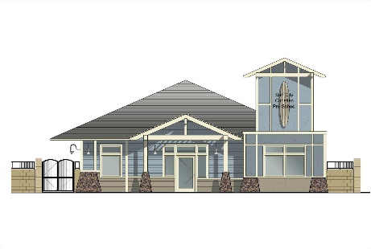
Surf City Christian
Child Development Preschool
5452 Heil Avenue, Huntington Beach, CA 92649
Phone: (714) 846-0316
office@surfcitychristian.com
www.surfcitychristian.com
New Family Application 2019-2020

Date: ___________ Requested Start Date: ___________
Child’s Name: ___________________________ Male/Female Date of Birth: __________
Child’s Address:__________________________________________________________
Mother/Guardian Name: _______________ Father/Guardian Name: ________________
Home Address: _____________________ Home Address: _______________________
City: _________________ Zip: ________ City: _________________ Zip: __________
Home Phone: ( ) __ - ______ Home Phone: ( ) - _____________
Cell Phone: ( ) - Cell Phone: ( ) -_______________
Email Address: _____________________ Email Address: _______________________
Employer: _ Employer: __________________________
Is your child potty trained: Yes No Allergies: ________________________________
What is the expected year your child will start kindergarten? (Circle One) 2019 2020 2021 2022
Please list any other child care facilities your child has attended _________________________
_____________________________________________________________________
Is there any special information you would like us to know about your child?
_____________________________________________________________________

REQUESTED PROGRAM & DAYS OF ATTENDANCE
Circle Room and desired days/time
Program Request: Star Fish Sea Turtles Surfers 2-3 years 3-4 years 4-5 Pre-K
1st Choice: M T W TH F Full days Am ½ Days Pm ½ Days
2nd Choice: M T W TH F Full days Am ½ Days Pm ½ Days

Notes: ____________________________________________________________________________________________________________
______________________________________________________

PLEASE REMEMBER THIS IS ONLY A REQUEST. WE WILL DO OUR BEST TO ACCOMMODATE EACH FAMILY. THANK YOU, S.C.C.

$225.00 NON-REFUNDABLE REGISTRATION FEE DUE UPON PLACEMENT

OFFICE USE ONLY
Paid Reg. Fee_____________#______ Start Date ____________
Program Files—Room/Days offered: ___________________________________
On waitlist in Computer: ___________________________________________

