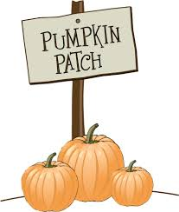 October 2019
Sunday | Monday | Tuesday | Wednesday | Thursday | Friday | Saturday
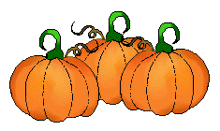  SCC annual Pumpkin Patch this Month….you are welcome to bring any pumpkin donations big or small. | 30 | 1  Star Fish  Back to School Night  5:00-6:00 pm  SCC Closed at 4:00pm | 2  Sea Turtles  Back to School Night  5:00-6:00 pm  SCC Closed at 4:00pm | 3  Surfers & Sailors  Back to School Night  5:00-6:00 pm  SCC Closed at 4:00pm | 4 | 5
6 | 7 | 8 | 9  Grandparents Day Celebration | 10 Grandparents Day Celebration | 11 | 12
13  Food Drive Collection Starts This Week----- | 14 | 15 | 16 | 17 | 18 | 19
20 | 21 | 22  Music with  Mrs. Sharon | 23 | 24 | 25  Music with  Mrs. Sharon  *Last Day for Food Drive donations | 26
27 | 28  Happy Birthday  Ms. Stephanie Hughes  (Kinder Teacher) | 29 | 30  Halloween Parade! | 31  Halloween Parade!

